Santa’s Secret Room
This year Santa’s Elves will be opening up their shopping room on Tuesday 17th December. If you have any presents (unused), wrapping paper or tags you would like to donate to the elves they would be grateful for them at any time. On the day children can go along to the room and buy a present for a member of their family. The children love being able to choose, wrap and tag a very reasonably priced present which they can then take home.
If you can help out on the day please let us know.
Christmas Lunch
We will be serving Christmas Lunch on Friday 13th December. On that day the menu will change and the choice of main course will be Turkey or Quorn Fillet.
Getting in Touch
Recently the Leadership Team have been doing a lot of class cover and therefore have not always been able to speak to people when they phone or pop in. We do always get the messages and try to respond as soon as possible. Hopefully we will not be in class as much over the next few weeks and will be able to catch up with anyone we have not managed to speak to.
Needles/Broken Glass
We have been alerted to needles and broken glass along the edge of the school grounds near the bushes at the bottom of the playing fields. We have now had these cleared up but are disappointed that some people have been irresponsible and have created potential risk to our youngsters. To keep children safe they will not be allowed to play in the bushes area. I know they will be disappointed, but we would rather they were playing in areas where it was safe.
If you see anything like this again please let us know, and if you know who is throwing needles around please let the police or community wardens know.
Healthy Tuckshop
Over the past few weeks we have noticed an increase in the number of children who have blue lips and tongues after eating sweets which are full of E numbers and sugar. A favourite at the moment is ‘Tongue Painter’ which contains E133 which because of its side effects has already been banned in some countries. Eating these sweets, and other similar sweets, does not put children in a good place to learn. Please have a chat to your child about eating these sweets. Hopefully now the Halloween sweets have been eaten we will see a return to healthy snacks. Our tuckshop is open every day with reasonably priced fruit, yoghurts, cheese, milk and water.
School Improvement Plan
Ever year each school produces a plan of what they wish to develop and improve. Attached is a pictorial summary of our current plan. If you wish to see more detail you will find the full plan on our school website at http://craigowl.ea.dundeecity.sch.uk
Dates for Diary
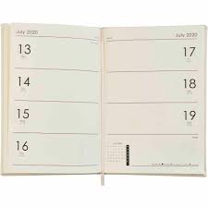
I have attached a list of dates for your diary though to the beginning of session 2020-2021. Please keep these handy so that you know what is planned. As we plan more events we will update these and send the out to you.

Staffing News
You may remember in a previous newsletter I told you that Mrs Evetts was off ill. She had hoped to be back by the October holidays but has now been told by her doctor to stay off until Christmas. We have now managed to get Mrs McLean to cover P6A on a Thursday and Friday. She is in today meeting the class and will start with us next week.
Mrs Robb is currently off ill and Mrs Chaudhuri is currently working with P3B. We wish Mrs Robb a speedy recovery and look forward to seeing her soon.
Recently Mrs McLorinan went for interview and has been appointed as Depute Head Teacher at Victoria Park Primary School. We are not sure of her exact starting date but it will be within the next few weeks. Although we will miss her here at Craigowl we congratulate her on her promotion and wish her well for the future.
Mrs Crowe, Mrs Hill and Mrs Ramsay have all been offered secondments to work as nursery teachers in various schools in the city. Again we don’t have definite starting dates for them but we will keep you informed as to arrangements for their classes. We wish them all well for their secondment and are happy that Mrs Ramsay is just moving along the corridor and will be the nursery teacher here at Craigowl.
Parking Issues
I have again had the issue of parents parking on the pavement raised by some of our neighbours and by parents. This week I heard that some children nearly got knocked down as they had to move onto the road because a car was blocking the pavement. As well as endangering children’s lives these irresponsible drivers are causing issues for parents/carers with prams and buggies and for wheelchair users.
You have heard in the media that the Scottish Parliament is making parking on the pavement illegal …..let’s not wait until this become law, lets act now! I’d urge everyone to park responsibly and make sure all the children are safe.
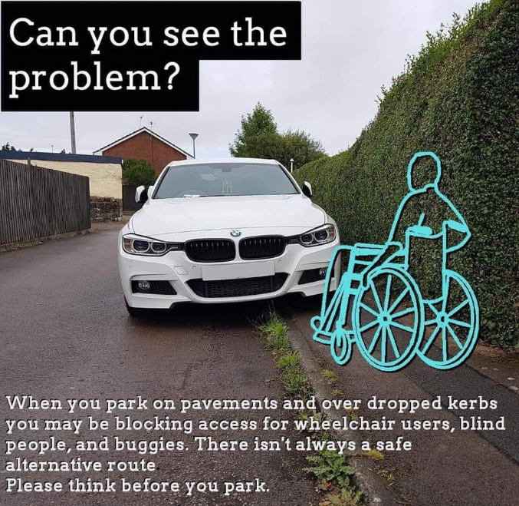
I saw this picture on the internet recently and thought it was worth sharing.
Yours faithfully,
Euan C Smith

