Craigowl Primary School
15th August 2017
Dear Parents,
I am sure you all breathed a sigh of relief as you sent your children off to school this morning. As far as the weather is concerned this summer has not been great but I hope all the children had a good break and found plenty to keep them occupied. Paul Wilson, our School and Family Development Worker, tells me that the Family Fun Days which were held across the local area were a great success with lots of families joining in the fun so hopefully you haven’t heard ‘I’m bored!’ too often.
Staff News
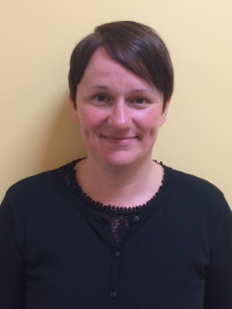
At the end of last session we said goodbye to Mrs Houghton and Miss Tosney from the nursery team. We are now delighted to welcome Mrs Rachael Anderson, Early Years Educator, and Miss Nicki Ward, Early Years Support Assistant. I am sure that they are both going to be an asset to the team bringing with them a range of skills and lots of enthusiasm. We look forward to getting to know them, and I am sure you will all join with me in welcoming them to the Craigowl Team.
Miss Ward
Mrs Anderson
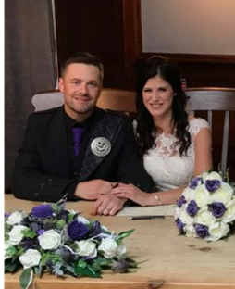
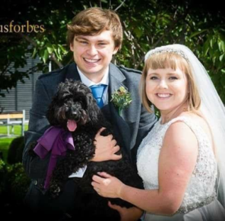
Over the summer two of our teachers got married. Miss Cooper is now Mrs Petrie and Miss Robertson is Mrs Mcleod. We would like to wish both Mr and Mrs Petrie, and Mr and Mrs McLeod all the best for their future together.
Mr & Mrs McLeod
Mr & Mrs Petrie

In June we said ‘au revoir’ to Mrs McLorinan and Mrs Thomson who have both taken up secondments. Mrs McLorinan is now Acting Depute Head at Glebelands Primary and Mrs Thomson is now Transition Teacher working across the Baldragon Cluster. We wish them well in their new posts and look forward to welcoming them back at the end of their secondment. Mrs Robb will be Acting Principal Teacher covering Mrs McLorinan’s duties and I look forward to her being part of the leadership team
We also said goodbye to Miss Anderson who completed her NQT year with us and has now taken up a post at Ancrum Road Primary School and we wish her well for her future there.
As you will be aware from previous newsletters and from articles in the press each school has been allocated money from the Scottish Government to reduce the attainment gap. As part of the drive towards this I have appointed Mrs Ramsay as Acting Principal Teacher to take an overview of all the work we are doing in this area.
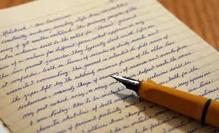
Important Information
Over the next two weeks there will be a lot of important information coming out and I wanted to highlight this so you could look out for it.
On Wednesday 16th August – we are sending out two letters. One will be about ParentPay (only for those not currently using ParentPay) and the other is about our Christmas Outings (I know it is only August!!)
On Friday 18th August we are sending out a letter about Class Dojo and our revised Behaviour Policy
On Monday 21st August we will send out a letter about Learning Conversations (previously called Pupil Progress Meetings) giving details of when you can come in to discuss your child’s learning.
On Wednesday 23rd August a letter will be sent out to parents of children in P1- P3 re Curriculum Evenings
Please check school bags so that you find all these letters.
For daily updates of what is happening across the school please follow us on Twitter at @CraigowlPrimary
Just a wee reminder that you can support the school through easyfundraising.org.uk when you shop online. Log on to easyfundraising.org.uk, choose Craigowl as your charity and then search for the site you want to use eg Amazon, Thomas Cook etc. You then order your goods as usual and the retailer will donate some money to the school.
Lost Property
Please help us reduce the amount of lost property in school by naming everything your child will bring to school, particularly items of clothing. Please do it NOW!

The team here at Craigowl look forward to working with you and your children over the coming year. If there is anything you would like to discuss with us please contact the school office on 307680.
Yours sincerely,
Euan C Smith
Euan C Smith
Head Teacher

